**PROJECT REPORT**

A simple Python and machine learning project which aims at recommending relevant products to the user according to the data of previous purchases on the platform.

Data set saved in csv file is traversed and manipulated using numPy and Pandas to recommend a "You can also buy" products according to the maximum scores achieved by every single product.

Input from user is like, "what product are you looking for?", when a user enters a product, the algorithm will recommend some other products relevant to that searched product according to the data saved of previous purchases.

INPUT

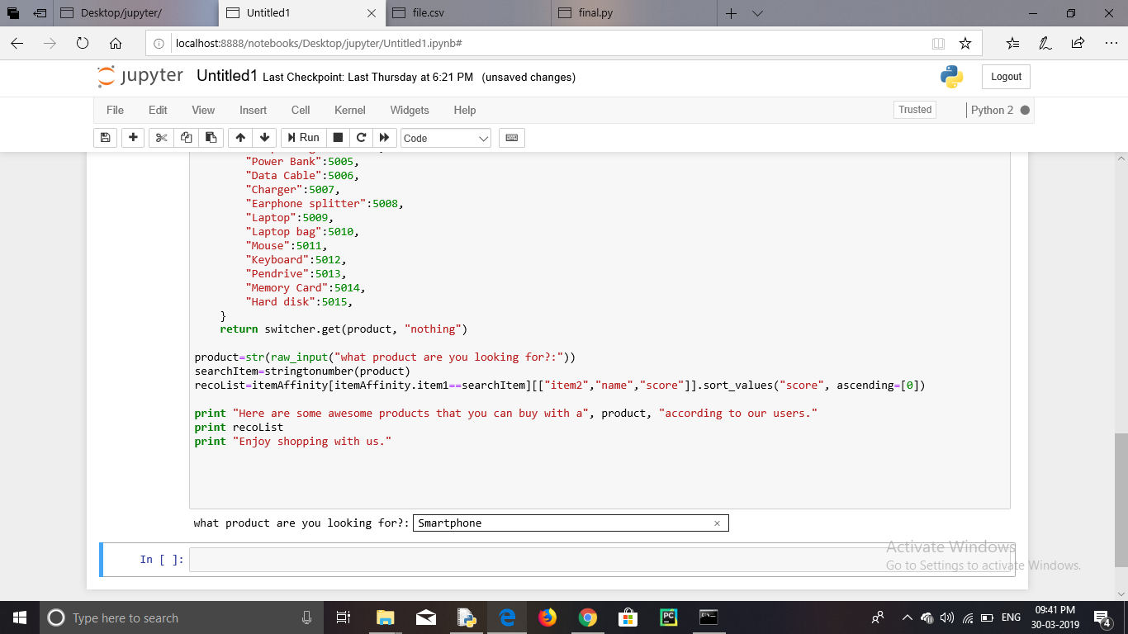

OUTPUT

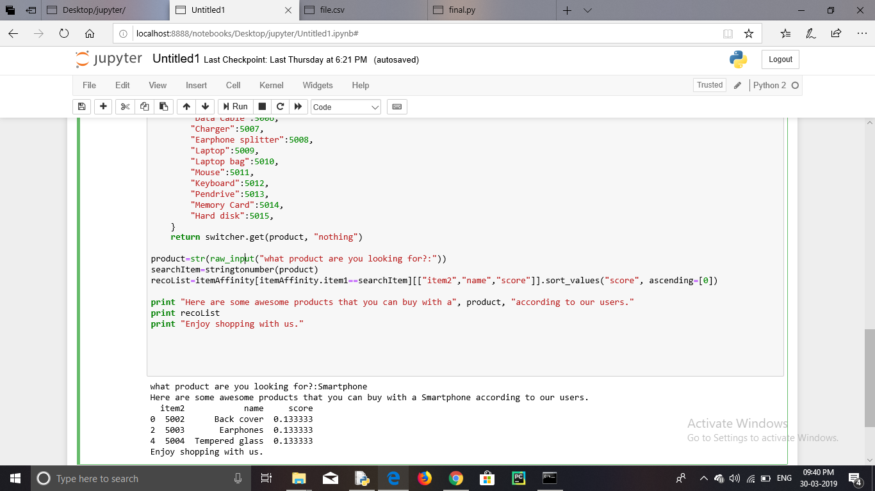

Thank You.